PMA Technical Assessment
PM Accelerator Mission
By making industry-leading tools and education available to individuals from all backgrounds, we level the playing field for future PM leaders. This is the PM Accelerator motto, as we grant aspiring and experienced PMs what they need most – Access. We introduce you to industry leaders, surround you with the right PM ecosystem, and discover the new world of AI product management skills.
Project Overview
- Objective: Analyze the Global Weather Repository dataset to forecast future weather trends using data science techniques.
- Assessment Track: Advanced
- Name: Mohammad Ibtesam Khan
- Submission Date: April 22nd, 2026
Dataset
- Source: Kaggle — "nelgiriyewithana/global-weather-repository"
- File: GlobalWeatherRepository.csv
- Download size: ~10.8 MB
- Shape: 136,828 rows × 41 columns
Unique Analysis
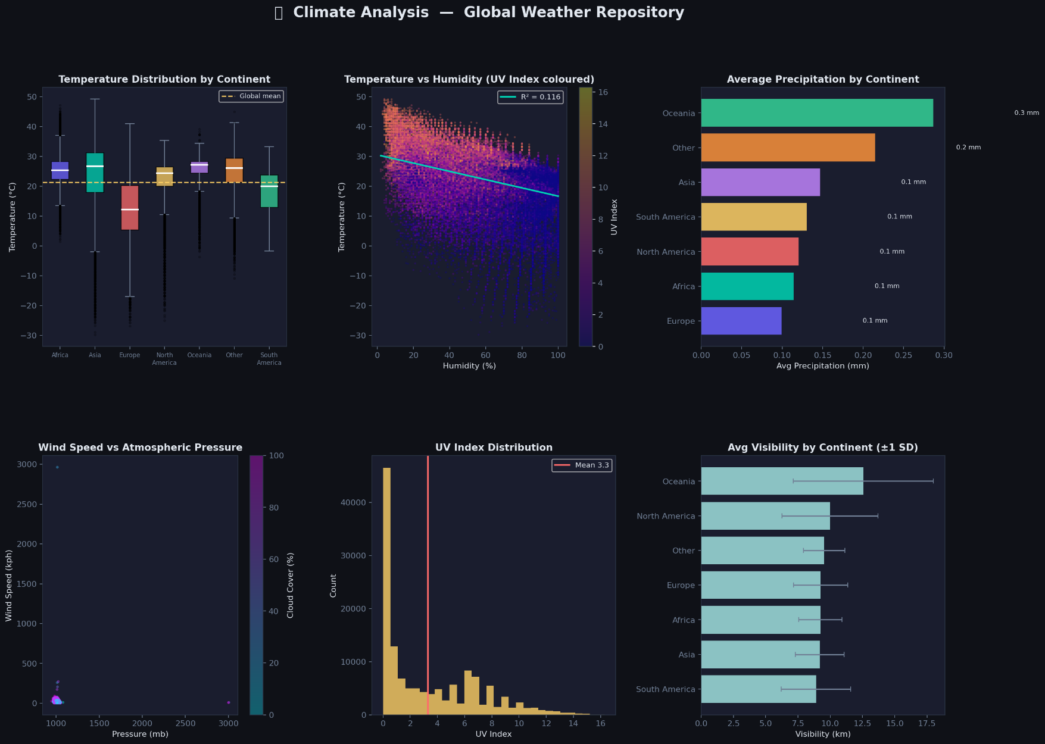
FIGURE 1 — CLIMATE ANALYSIS

FIGURE 1 — CLIMATE ANALYSIS
Subplot (a): Temperature Distribution by Continent [Box Plot]
• Grouped box plots for each continent showing temperature spread in °C.
• Median lines in white; outliers shown as small semi-transparent dots.
• A global mean reference line (dashed amber) is overlaid.
• Insight: Tropical continents (Africa, Asia, North America) show higher median temperatures; Europe
and Oceania have wider spread and cooler values; North America shows diverse distributions.
Subplot (b): Temperature vs Humidity [Scatter Plot]
• X-axis: Humidity (%); Y-axis: Temperature (°C)
• Points coloured by UV Index.
• Insight: Moderate negative correlation between humidity and temperature;
higher UV index concentrates in drier, hotter regions.
Subplot (c): Average Precipitation by Continent [Horizontal Bar Chart]
• Mean precipitation (mm) per continent, sorted ascending.
• Values annotated at bar ends.
• Insight: Europe and Africa typically have the highest mean precipitation.

Subplot (d): Wind Speed vs Atmospheric Pressure [Scatter Plot]
• X-axis: Pressure (mb); Y-axis: Wind Speed (kph)
• Insight: Higher cloud cover tends to appear at moderate pressure ranges. Also, wind speed tends to
increase as Atmospheric pressure decreases.
Subplot (e): UV Index Distribution [Histogram]
• 30-bin histogram of UV index values.
• Mean UV value overlaid as vertical dashed line.
• Insight: Most of the records have UV-index within [0 – 1] range.
Subplot (f): Average Visibility by Continent [Horizontal Bar Chart]
• Mean visibility (km) per continent with ± 1 standard deviation error bars shown in muted grey.
• Insight: Oceania tends to have the highest average visibility.

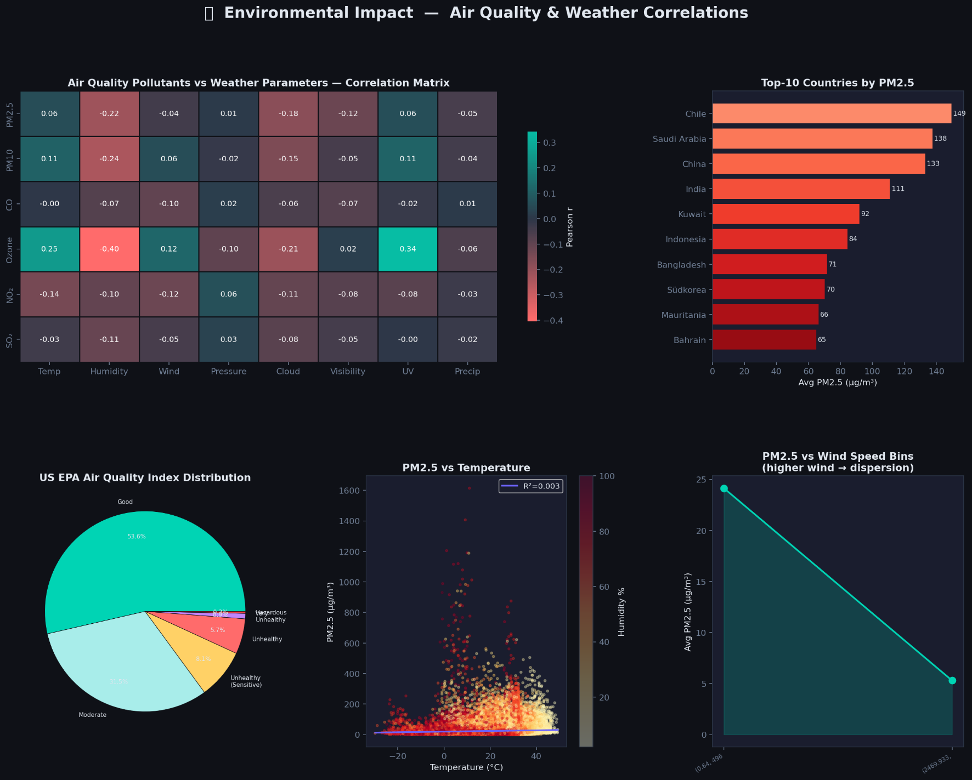
FIGURE 2 — ENVIRONMENTAL IMPACT: AIR QUALITY & WEATHER CORRELATIONS

Subplot (a): Air Quality Pollutants vs Weather Parameters [Correlation Matrix]
• Rows: PM2.5, PM10, CO, Ozone, NO₂, SO₂
• Columns: Temperature, Humidity, Wind, Pressure, Cloud, Visibility, UV, Precipitation
• Coloured with a custom diverging red–navy–teal colormap centred at 0.
• Pearson correlation values annotated on each cell.
• Insights:
- Temperature shows positive correlation with pollutants.
- Ozone has highest correlations with temperature and UV-index.
Subplot (b): Top-10 Countries by Average PM2.5 [Horizontal Bar Chart]
• Red gradient bars listing the 10 most polluted countries by mean PM2.5.
• Values annotated at bar ends in μg/m³.
• Insight: Mostly Asian countries top the list.

Subplot (c): US EPA Air Quality Index Distribution [Pie Chart]
• Categories: Good, Moderate, Unhealthy (Sensitive), Unhealthy, Very Unhealthy, Hazardous
• Insight: The majority of global observations fall in the "Good" (53.6%) or "Moderate" (31.5%)
categories.

Subplot (d): PM2.5 vs Temperature [Scatter Plot]
• X: Temperature (°C); Y: PM2.5 (μg/m³)
• Points coloured by humidity (Yellow or Red colormap).
• Linear regression line with R² annotated.
• Insight: Positive but noisy relationship; extreme PM2.5 outliers appear at moderate temperatures with
higher humidity.
Subplot (e): PM2.5 vs Wind Speed Bins [Line + Fill Chart]
• Wind speed divided into 6 equal-frequency bins; mean PM2.5 per bin.
• Insight: Clear downward trend — as wind speed increases, average PM2.5 decreases substantially,
confirming atmospheric dispersion.

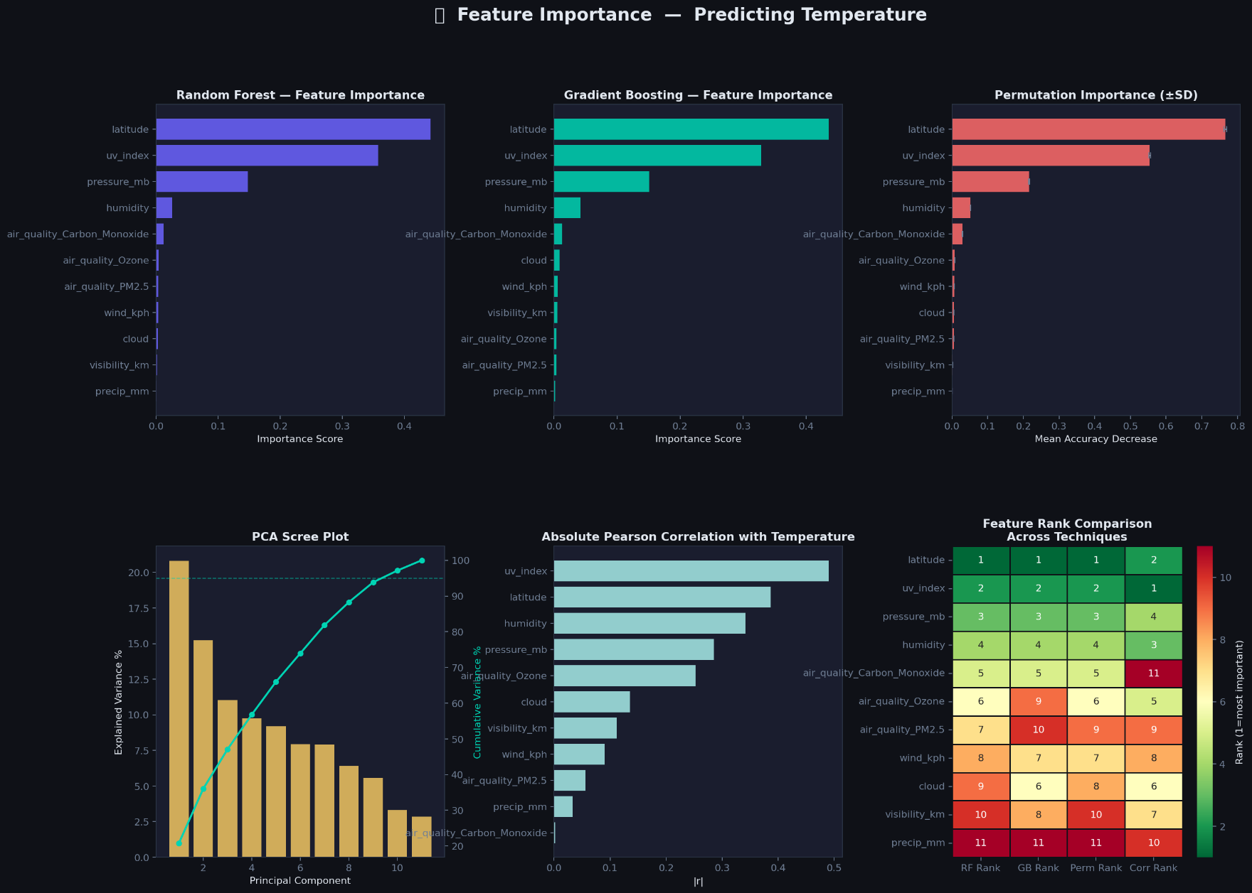
FIGURE 3 — FEATURE IMPORTANCE IN PREDICTING TEMPERATURE
Subplot (a): Random Forest Feature Importance [Horizontal Bar]
• RandomForestRegressor: 200 estimators, max_depth=8, random_state=42
• Top features: latitude, humidity, uv_index, pressure_mb

Subplot (b): Gradient Boosting Feature Importance [Horizontal Bar]
• GradientBoostingRegressor: 150 estimators, max_depth=4, random_state=42
• Generally agrees with Random Forest; slight re-ordering in mid-tier features.

Subplot (c): Permutation Importance (±SD) [Horizontal Bar with Error Bars]
• 15 repeats of permutation importance using the Random Forest model.
• Error bars (±1 SD) indicate stability of each feature's importance.
• Top features: latitude and humidity most impactful; small error bars indicate reliable estimates.
Subplot (d): PCA Scree Plot [Bar + Line]
• Data standardised with StandardScaler; PCA fitted on 11 features.
• Bar chart shows % of variance explained per principal component.
• 95% cumulative variance reference line (dashed teal) overlaid.
Subplot (e): Absolute Pearson Correlation with Temperature [Horizontal Bar]
• Direct linear correlation of each feature with temperature_celsius.
• latitude shows the strongest linear relationship, while humidity also shows notable correlation.
Subplot (f): Feature Rank Comparison Across Techniques [Annotated Heatmap]
• Columns: RF Rank, GB Rank, Permutation Rank, Correlation Rank.
• Rows sorted by RF Rank.
• Coloured by Red, Yellow, and Green (low = most important i.e. green).
• Insight: latitude consistently ranks #1 across all four methods.

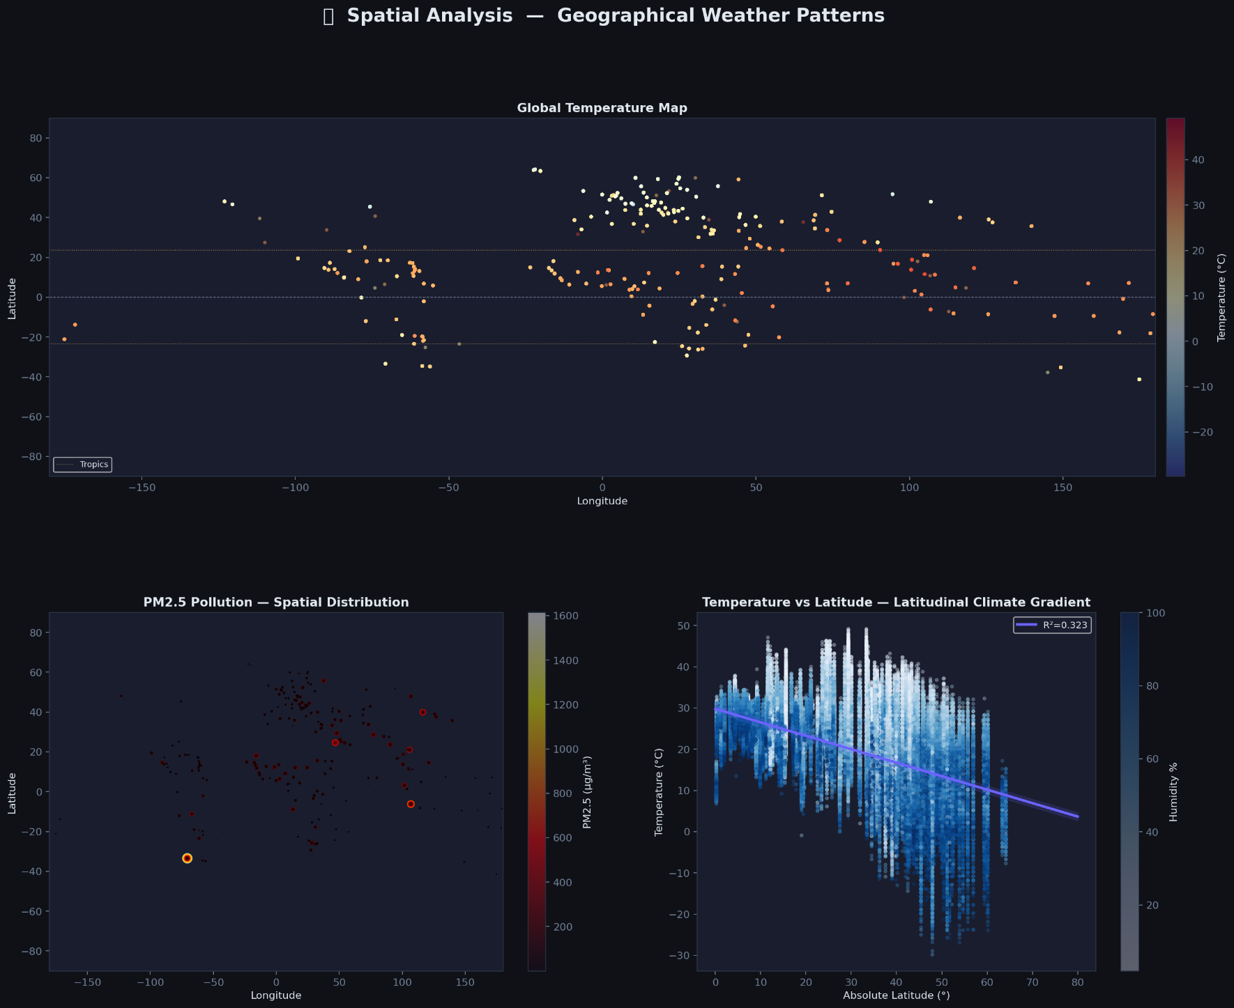
FIGURE 4 — SPATIAL ANALYSIS: GEOGRAPHICAL WEATHER PATTERNS

Subplot (a): Global Temperature Map [Full-Width Scatter Map]
• Longitude on X-axis, Latitude on Y-axis.
• Points coloured by temperature_celsius (blue=cold, red=hot).
• Reference lines for equator (dashed grey), Tropics of Cancer/Capricorn
• Insight: Clear band of high temperatures between ±23.5°; polar regions appear in blue; desert regions
in orange-red.

Subplot (b): PM2.5 Pollution — Spatial Distribution [Bubble Map]
• Longitude on X-axis, Latitude on Y-axis, and bubble size = PM2.5 value / 15
• Insight: High PM2.5 clusters in South Asia, East Asia, and Middle East.

Subplot (c): Temperature vs Absolute Latitude [Scatter + Regression Band]
• X-axis: |Latitude| (0–80°); Y-axis: temperature_celsius.
• Points coloured by humidity (Blues colormap).
• Linear regression line with R² and ±2 SE confidence band overlaid.
• Insight: Strong negative relationship — temperature decreases significantly as absolute latitude
increases.

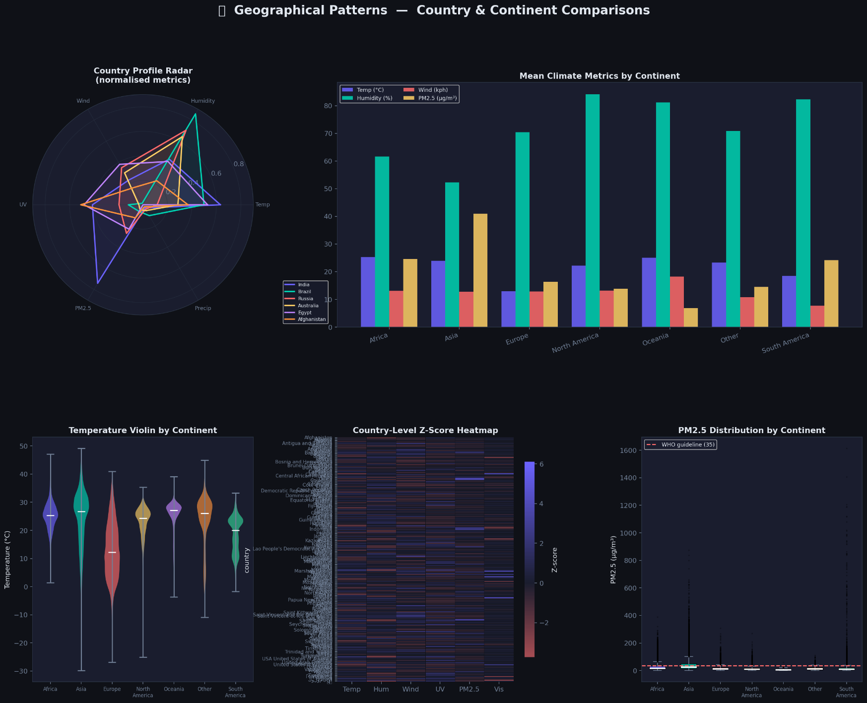
FIGURE 5 — GEOGRAPHICAL PATTERNS: COUNTRY & CONTINENT COMPARISONS
Subplot (a): Country Profile Radar Chart [Polar Axes]
• Six normalised metrics: Temperature, Humidity, Wind, UV, PM2.5, Precip.
• Six representative countries: India, Afghanistan, Brazil, Russia, Australia, Egypt.
• Each country plotted as a coloured line + shaded polygon.
• Insight: India leads in Temperature and PM2.5, while Brazil leads in humidity.
Subplot (b): Mean Climate Metrics by Continent [Grouped Bar Chart]
• Four metrics: Temperature (°C), Humidity (%), Wind (kph), PM2.5 (μg/m³).
• Grouped bars per continent with distinct accent colours.
• Insight: North America with highest humidity; Asia shows the highest PM2.5.

Subplot (c): Temperature Violin by Continent
• Violin plots showing full distribution of temperature °C per continent.
• White median indicator lines; body colours per continent.
• Insight: Europe and Asia had wide range of temperatures.

Subplot (d): Country-Level Z-Score Heatmap
• Metrics: Temp, Humidity, Wind, UV, PM2.5, Visibility.
• Each country's normalised deviation from the mean (Z-score).
• Coloured with a diverging red–navy–indigo palette.
• Insight: Enables identification of countries that are extreme outliers on any single metric.

Subplot (e): PM2.5 Distribution by Continent [Box Plot]
• Same 7-continent breakdown; boxes coloured per continent.
• WHO guideline of 35 μg/m³ overlaid as a dashed red line.
• Insight: Asia's median PM2.5 significantly exceeds the WHO guideline; Africa and South America hover
near the boundary; North America and Oceania are well below it.
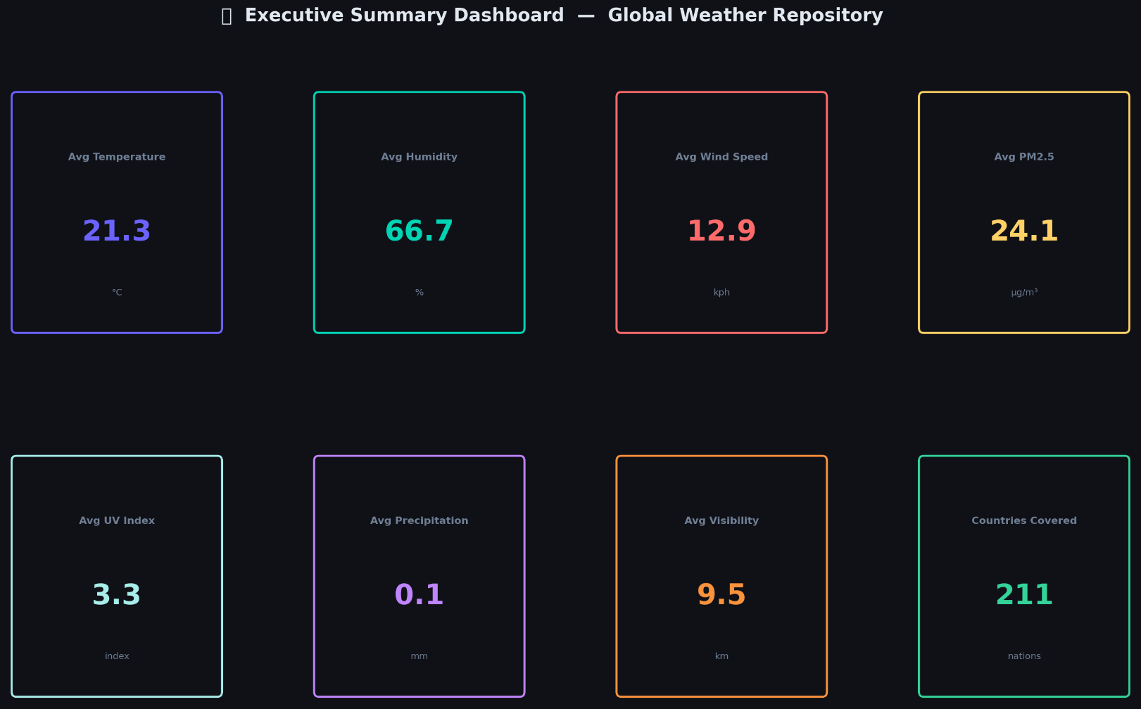
FIGURE 6 — EXECUTIVE SUMMARY DASHBOARD

Advanced EDA
Anomalies Detection
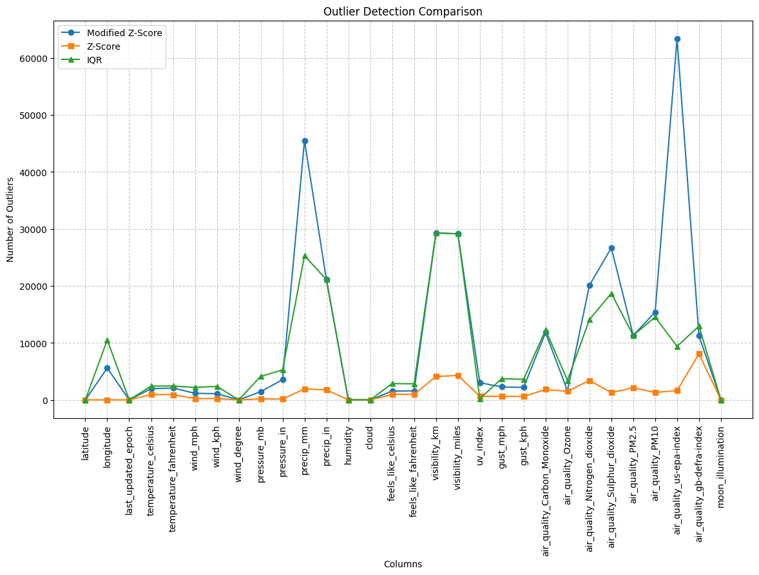
FIGURE 7 — Z-Score, Modified Z-Score, & IQR
METHOD 1 — Z-Score Method: A value is flagged as an outlier if |z| > 3 (i.e., more than 3 standard deviations (SD) from the column mean).
METHOD 2 — IQR (Interquartile Range) Method: Values outside this range are flagged as outliers.
• Lower bound = Q1 − 1.5 × IQR
• Upper bound = Q3 + 1.5 × IQR
METHOD 3 — Modified Z-Score Method: Uses the Median Absolute Deviation (MAD) instead of SD.
• More robust to heavily skewed distributions.
• Threshold: |Modified Z-Score| > 3.5.
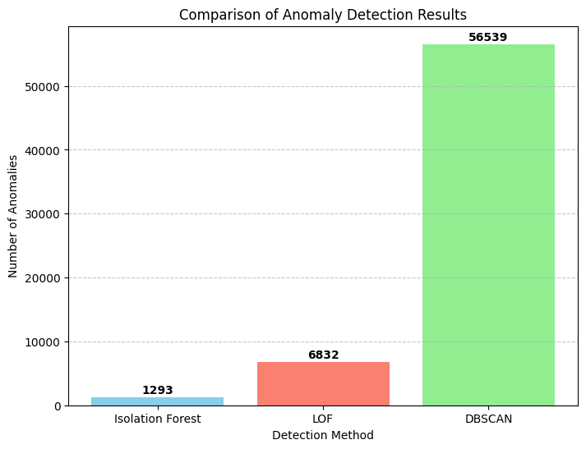
FIGURE 8 — ISOLATION FOREST, LOF, & DBSCAN

Isolation Forest: Detects anomalies by randomly isolating data points using tree-structure, with outliers being easier to separate.
Local Outlier Factor (LOF): Finds anomalies by comparing how densely a point’s neighborhood is packed relative to others nearby.
Density-Based Spatial Clustering of Applications with Noise (DBSCAN): Groups points into clusters based on density, labeling sparse points as anomalies.
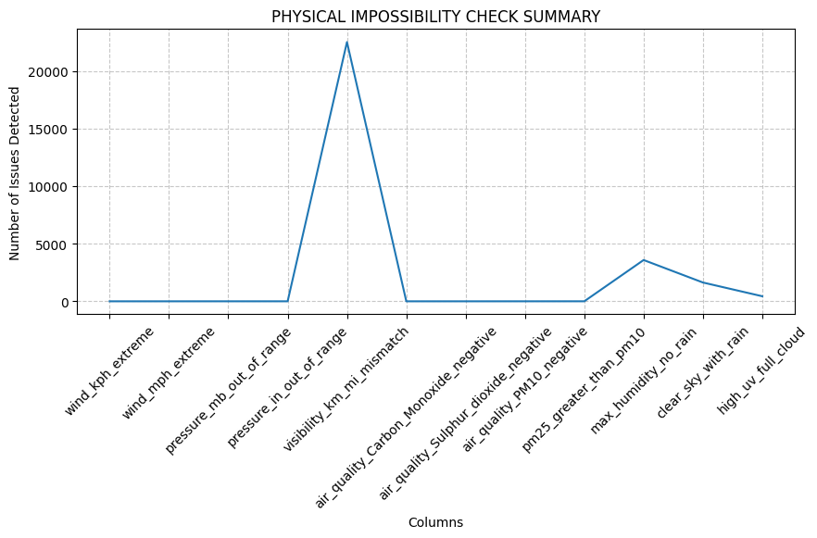
FIGURE 9 — PRACTICALLY IMPOSSIBLE ANOMALIES
Integrated physical checks to detect anomalies.
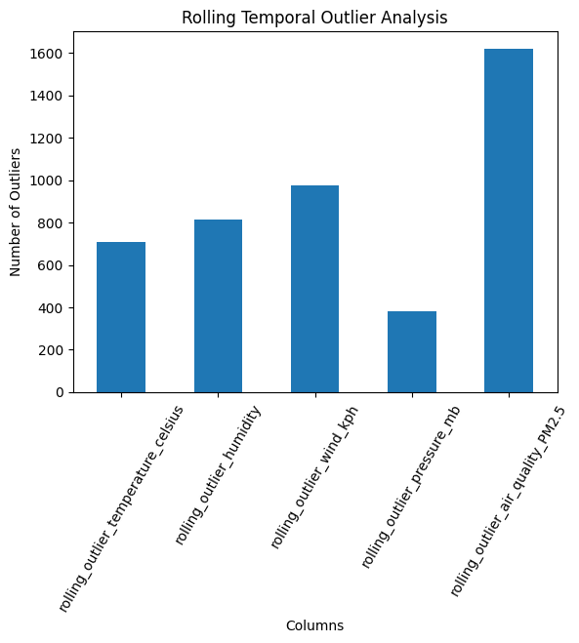

FIGURE 10 — Rolling Mean Outlier Detection In TEMPERATURE, HUMIDITY, WIND SPEED, PRESSURE, & AIR QUALITY PM2.5
Formula: Rolling Mean ± (3 * Rolling Standard Deviation)

Forecasting Models

Extreme Gradient Boosting (XG Boost)
Library: XGBoost (xgb.XGBRegressor)
N_Estimators: 150
Learning Rate: 0.05
Maximum Depth: 12
Objective : Mean Squared Error
DATA SPLIT:
Train | 70%
Test | 30%
Random State | 42

EVALUATION RESULTS:
Metric | Value
Mean Squared Error (MSE) | 13.5294
Mean Absolute Error (MAE) | 2.4027
R² Score | (85.62%)

LSTM (Long Short-Term Memory) Recurrent Neural Network

MOTIVATION:
Temperature is inherently time-series data. Therefore, LSTM, a Recurrent Neural Network (RNN), can capture temporal dependencies that other ML models like XGBoost miss.

DATA PREPARATION FOR LSTM:
• Sequences created per location to avoid cross-location contamination.
• window_size = 24.
• For each location with >24 observations, sliding windows of 24 time steps are created; the target is the
temperature 24 steps ahead.
• Features (excluding location_name) StandardScaler-normalised.
• Split:
Train | 70%
Test | 30%
Random State | 42

ARCHITECTURE (Sequential):
Layer 1: LSTM(16 units, dropout=0.2, recurrent_dropout=0.2, return_sequences=True)
Layer 2: LSTM(8 units, dropout=0.2, recurrent_dropout=0.2, return_sequences=True)
Layer 3: Bidirectional(LSTM(8 units, dropout=0.2, recurrent_dropout=0.2))
Layer 4: Dense(4, activation='leaky_relu')
Layer 5: Dense(2, activation='leaky_relu')
Layer 6: Dense(1, activation=’linear’) [output layer — single temperature value]

TRAINING CONFIGURATION:
Optimizer : Adam (learning_rate=0.003)
Loss : Mean Squared Error (MSE)
Metrics : MAE
Epochs : 2
Batch size : 32
Validation : X_test_reshaped / y_test

TRAINING HISTORY:
Epoch 1: Train Loss: 70.9139 | Train MAE: 5.7652 | Val Loss : 20.7868 | Val MAE : 3.2695

Epoch 2: Train Loss: 24.4378 | Train MAE: 3.5961 | Val Loss : 16.7531 | Val MAE : 2.9696

FINAL TEST EVALUATION RESULTS:
Metric | Value
Final Test MAE | 2.9696
R² Score | 82.13%

DISCUSSION:
• The LSTM achieves a strong R² of ~82.1% even with only 2 training epochs.
• The validation loss dropped sharply from Epoch 1 to Epoch 2, indicating the model was still learning, hence more epochs would likely improve performance further.
• MAE of 2.97 °C is slightly worse than XGBoost's 2.40 °C, but XGBoost uses all data simultaneously whereas LSTM operates on per-location time series
(a harder, more realistic task).
• The Bidirectional LSTM in Layer 3 allows the model to process temporal
context from both forward and backward in the sequence, enhancing pattern
recognition.
• Dropout regularisation (20%) prevents overfitting despite the limited
training data per location.
• The leaky_relu activation in dense layers prevents dying neuron issues.

MODEL COMPARISON SUMMARY:

┌──────────────────────┬───────────┬────────────────────────────────────────┐
│ Model │ R² Score │ MAE │ Notes │
├──────────────────────┼───────────┼────────────┼──────────────────────────┤
│ XGBoost Regressor │ 0.8562 │ 2.4027 °C │ Cross-sectional; fast │
│ LSTM (2 epochs) │ 0.8213 │ 2.9696 °C │ Time-series; per-city │
└──────────────────────┴───────────┴────────────┴──────────────────────────┘

Both models perform well. XGBoost edges ahead in raw accuracy due to its
ensemble nature and deep tree depth. LSTM shows strong promise and would
likely surpass XGBoost with more epochs and potentially more training data.

